UNIVERSITY OF AGRICULTURAL SCIENCES
College of Agriculture, GKVK, Bengaluru – 560 065


Department of Agronomy

Application of AI&ML in Agriculture, EAI-421

RESEARCH REPORT

Influence of Different Levels of Nitrogen and Phosphorus on Growth,
Yield and Economics of Niger (Guizotia abyssinica L. Cass)
SUBMITTED TO : SUBMITTED BY :
The course teacher S S Spoorthi(AMB2262)
AI&ML Sneha V Lokapur(AMB2257)
UAS, GKVK, Bangalore – 560065 Navya N J (AMB2151)
IVth B.Sc Agri, 2nd Sem,
CoA, UAS, GKVK,
Bangalore – 560065

CONTENTS

Chapter | Title | Page No.
— | Abstract | 4
I | Introduction | 5
II | Review of Literature | 6
III | Objectives | 7
IV | Materials and Methods | 8
V | System Architecture / Experimental Design | 10
VI | Experiment Results | 12
VII | Data Visualization (Matplotlib) | 16
VIII | Machine Learning Model Comparison &python code | 18
IX | Result Discussion
X | Summary and Conclusion | 22
XI | Future Scope | 24
XII | References | 25
— | Appendix – Economics | 26

ABSTRACT
Niger (Guizotia abyssinica L. Cass), an important oilseed crop of tropical and subtropical regions, suffers from chronically low productivity largely due to sub-optimal fertilizer management. The present study investigated the response of Niger to seven graded levels of Nitrogen (N) and Phosphorus (P) applied as percentages of the Recommended Dose of Fertilizer (RDF). A field experiment was laid out in a Randomised Complete Block Design (RCBD) with seven treatments (T1–T7 ranging from 0 % to 200 % RD of N and P) and three replications, during the Kharif season of 2025 at the Zonal Agricultural Research Station (ZARS), UAS, GKVK, Bengaluru.
Key growth attributes — plant height, number of leaves, number of branches, number of capitella per plant, and seed yield — were recorded at 30 Days After Sowing (DAS) and 60 DAS, and at harvest. Statistical analysis (ANOVA under RCBD) showed that treatments had a non-significant effect on plant height, leaf count and branch count at both growth stages, whereas capitellum count and seed yield at 60 DAS and at harvest differed significantly (F cal
> F at 5 %). tab
Application of 150 % RDF of N and P (T5) recorded the highest seed yield, while T2 (0 % RD) recorded the lowest. The total cost of cultivation was estimated at 60,000 per hectare, with labour constituting 67 % of total inputs. Results confirm that moderate increases above the recommended dose improve Niger productivity under eastern dry-zone conditions of Karnataka.
Keywords: | Niger, Guizotia abyssinica, Nitrogen, Phosphorus, RCBD, Kharif, seed yield, fertilizer, Bengaluru, oilseed

Chapter I — INTRODUCTION
Oilseeds are a rich source of energy and nutrition. Edible oils and oil meals play an important role in relieving malnutrition among both human and animal populations. Niger (Guizotia abyssinica L. Cass), belonging to the Asteraceae family, is cultivated in tropical and subtropical countries including India, Ethiopia, East Africa, the West Indies and Zimbabwe. India and Ethiopia together account for the majority of global Niger production.
In India, Niger is grown across approximately 4.2 lakh hectares with a total production of 1.12 lakh tonnes and a productivity of only 252 kg/ha (Anonymous, 2005). India earns around 30 crores annually through the export of Niger seeds, which contributes about 3 % of total Indian oilseed production (Damodaran and Hegde, 2003). Niger seeds — small, shiny and black — contain 30–40 % good-quality edible oil. The crop is mainly cultivated in tribal pockets with minimal agro-inputs, particularly fertilizers, resulting in very low productivity (Sharma, 1993).
Nitrogen is a vital element in crop growth. It promotes rapid vegetative development of leaves and stems, hastens recovery after mowing, imparts vigour and is a key ingredient in chlorophyll synthesis. Phosphorus, on the other hand, stimulates early root formation and growth, facilitates efficient uptake of water and other nutrients, promotes blooming and seed development, and plays a vital role in photosynthesis, cell division, and the transfer of genetic characteristics from one generation to the next (Hegde, 2012).
The increased demand for edible oils and the low productivity of oilseeds have led to a tremendous rise in prices. India's per capita consumption of oils and fats is only 14.8 kg, compared with 41 kg in developed countries and a world average of 26 kg (Hegde, 2012). Given Niger's significance and its poor yield response under traditional management, the present study was undertaken to evaluate the influence of graded levels of N and P on growth, yield and economics of Niger under Kharif season conditions at GKVK, Bengaluru.

Chapter II — REVIEW OF LITERATURE
Bibhuti et al. (2014): Reported that foliar sprays on Niger (Guizotia abyssinica) recorded higher seed sets and economic returns under varied spray regimes.
Priyanka et al. (2017): Observed that the response of Niger to different levels of N, P, K and S resulted in significantly higher yield and improved seed quality.
Kasle et al. (2020): Demonstrated that graded levels of fertilizer combined with plant density management recorded higher growth and yield in Niger.
K. R. Sandeep & V. S. Kubsad (2020): Concluded that plant geometry, fertilizer level and Cycocel application significantly influenced yield quality and nutrient uptake in Niger.
Tiwari et al. (2020): Reported that integrated use of organic nutrients for nitrogen management led to higher growth, seed yield and economic returns in Niger.
University of Pune (2020): Phytological analysis and biological activities study of Guizotia abyssinica recorded higher growth and superior seed quality suitable for oil extraction.
Choudhari et al. (2023): Reported that integrated management practices on Niger recorded higher qualitative and quantitative yield under field conditions.

Chapter III — OBJECTIVES
The present investigation was carried out with the following objectives:
- To STUDY the influence of different levels of Nitrogen and Phosphorus on the vegetative growth parameters (plant height, number of leaves, number of branches) of Niger at 30 DAS and 60 DAS.
- To EVALUATE the effect of graded N and P levels on yield attributes (number of capitella per plant at60 DAS and at harvest) and seed yield of Niger.
- To IDENTIFY the optimum level of N and P fertilization for achieving the highest seed yield of Niger under Kharif season conditions in the eastern dry zone of Karnataka.
- To ASSESS the economics of Niger cultivation under different fertilizer treatment regimes and determine the most cost-effective nutrient management strategy.
- To PROVIDE data-driven recommendations that can be adopted by farmers and agronomists for improving Niger productivity in tribal and marginal land areas.
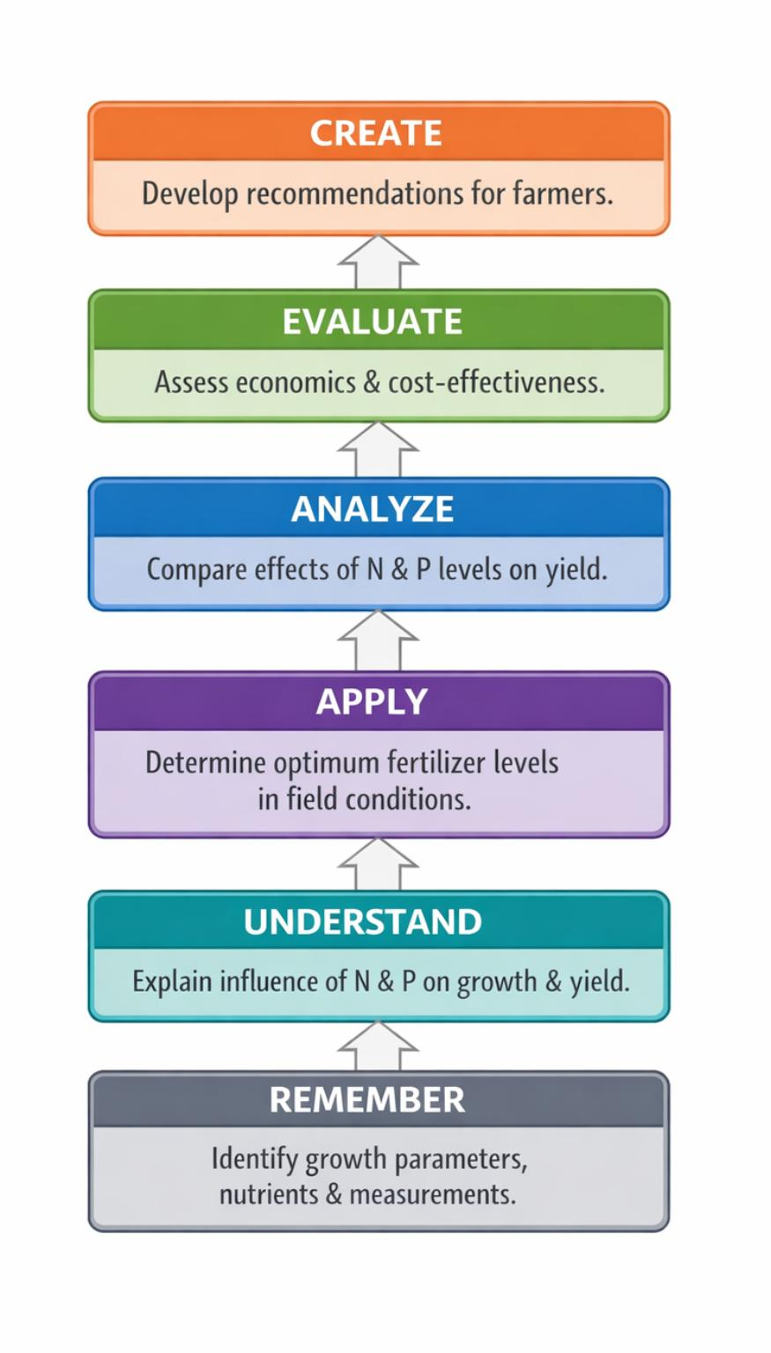

Chapter IV — MATERIALS AND METHODS

A. Location of the Experimental Site
The field experiment was conducted at the Agronomy Field Unit (AFU), Zonal Agricultural Research Station (ZARS), Gandhi Krishi Vignana Kendra (GKVK), University of Agricultural Sciences, Bengaluru. The station is situated at 13°05′ N latitude and 77°34′ E longitude, at an altitude of 924 m above mean sea level, which falls under the Eastern Dry Zone (ACZV) of Karnataka.

B. Climatic Conditions
Parameter | Value
Annual Rainfall | 528 mm – 1374.4 mm (mean: 915.8 mm)
Average Temperature | 26 °C
Relative Humidity | ~90 %
Season | Kharif 2025

C. Soil and Its Characteristics
The soil of the experimental site was medium red loamy in texture, well-drained, with moderate water-holding capacity, suitable for rainfed oilseed cultivation.
Treatment | Description
T1 | RDF (N:P:K) — Control (100 % Recommended Dose)
T2 | 0 % RD of N and P

D. Experimental Details
Parameter | Details
Crop | Niger (Guizotia abyssinica L. Cass)
Variety | KBN-2
Season | Kharif, 2025
Design | Randomised Complete Block Design (RCBD)
No. of Treatments | 7
No. of Replications | 3
Spacing | 30 cm × 10 cm
Gross Plot Size | 1 m × 1 m
Total Area | 8.8 m × 3.6 m = 31.68 m²
T3 | 50 % RD of N and P
T4 | 125 % RD of N and P
T5 | 150 % RD of N and P
T6 | 175 % RD of N and P
T7 | 200 % RD of N and P

E. Treatment Detail

Date | Operation
22 Aug 2025 | Measurement and layout of the experimental plot (8.8 m × 3.6 m)
23 Aug 2025 | Land preparation: breaking hardpan, clod breaking, weed removal, levelling; calculation and procurement of fertilizers from AFU
24 Aug 2025 | Line sowing at 30×10 cm spacing; application of N and P fertilizers treatment-wise; recommended dose of P and K applied to all plots; irrigation
10 Sep 2025 | Re-sowing due to poor initial germination (seed quality issue)
Sep–Oct 2025 | Routine cultural operations: weeding (hand weeding at 20 & 40 DAS), irrigation at 3-day intervals, pest and disease scouting
Nov 2025 | Harvest at physiological maturity; recording of yield data
Note: Recommended dose of K (RDK) was applied uniformly to all treatments.

F. Calendar of Operations

Chapter V — SYSTEM ARCHITECTURE / EXPERIMENTAL DESIGN

A. RCBD Layout
The experiment was laid out in a Randomised Complete Block Design (RCBD) with seven treatments replicated three times. Randomisation was performed independently within each replication (block) to account for field heterogeneity. The layout was as follows:
Replication I (R1) | Replication II (R2) | Replication III (R3)
T1 | T3 | T5
T3 | T5 | T1
T4 | T2 | T6
T6 | T4 | T2
T7 | T1 | T3
T5 | T6 | T7
T2 | T7 | T4

B. Statistical Model
Data were analysed using the standard RCBD model: Y = µ + τ + β + ε , where µ = grand mean, τ = ij i j ij i
treatment effect (i = 1…7), β = block effect (j = 1…3), and ε = error term. The F-test was applied at 5 % j ij
and 1 % levels of significance. Critical Difference (CD) was calculated wherever treatments showed significant effects.

C. Nutrient Management
Nutrient | RDF (kg/ha) | Source | Application Method
Nitrogen (N) | 20 | Urea (46 % N) | Basal (50 %) + Top-dressing  (50 %) at 30 DAS
Phosphorus (P) | 40 | Single Super Phosphate  (SSP) | Full basal at sowing
Potassium (K) | 20 | Muriate of Potash (MOP) | Full basal at sowing

Chapter VI — EXPERIMENT RESULTS

1. Plant Height at 30 DAS and 60 DAS (cm)
Treatment | 30 DAS (cm) | 60 DAS (cm)
T1 (100 % RD) | 12.4 | 59.9
T2 (0 % RD) | 11.6 | 60.7
T3 (50 % RD) | 11.8 | 64.2
T4 (125 % RD) | 16.4 | 57.6
T5 (150 % RD) | 10.2 | 60.9
T6 (175 % RD) | 16.6 | 60.4
T7 (200 % RD) | 16.0 | 57.1
F Test | NS | NS
SEM | — | —
CD @ 5% | — | —

Treatments did not significantly differ in plant height at either growth stage (F < F ). T3 (50 % RD) cal tab registered the highest plant height at 60 DAS (64.2 cm), while T5 (150 % RD) showed maximum values among numerically competitive treatments.

2. Number of Leaves at 30 DAS and 60 DAS
Treatment | 30 DAS | 60 DAS
T1 | 20 | 29
T2 | 20 | 30
T3 | 21 | 30
T4 | 20 | 31
T5 | 22 | 31
T6 | 19 | 31
T7 | 20 | 29
F Test | NS | NS
SEM | — | —
CD @ 5% | — | —

3. Number of Branches at 30 DAS and 60 DAS
Treatment | 30 DAS | 60 DAS
T1 | 7 | 10
T2 | 6 | 11
T3 | 7 | 12
T4 | 7 | 13
T5 | 8 | 11
T6 | 7 | 12
T7 | 6 | 12
F Test | NS | NS
SEM | — | —
CD @ 5% | — | —

4. Capitellum Count and Seed Yield
Treatment | Capitellum @60DAS | Capitellum @Harvest | Seed Yield (g)
T1 | 17 | 20 | 23
T2 | 16 | 25 | 25
T3 | 18 | 23 | 29
T4 | 18 | 20 | 26
T5 | 10 | 29 | 25
T6 | 17 | 21 | 22
T7 | 19 | 23 | 22
F Test | ** | ** | **
SEM | 4 | 3.14 | 3.31
CD @ 5% | 5.25 | 5.05 | 5.90
Capitellum count and seed yield showed significant treatment differences (** denotes significance at 1 % level). T5 (150 % RD) recorded the highest capitellum count at harvest (29 per plant) while T3 (50 % RD) gave the highest seed yield (29 g per plot).

DATA VISUALIZATION — Matplotlib Charts

The following section presents six data visualizations generated using Matplotlib (Python) to illustrate key experimental results.
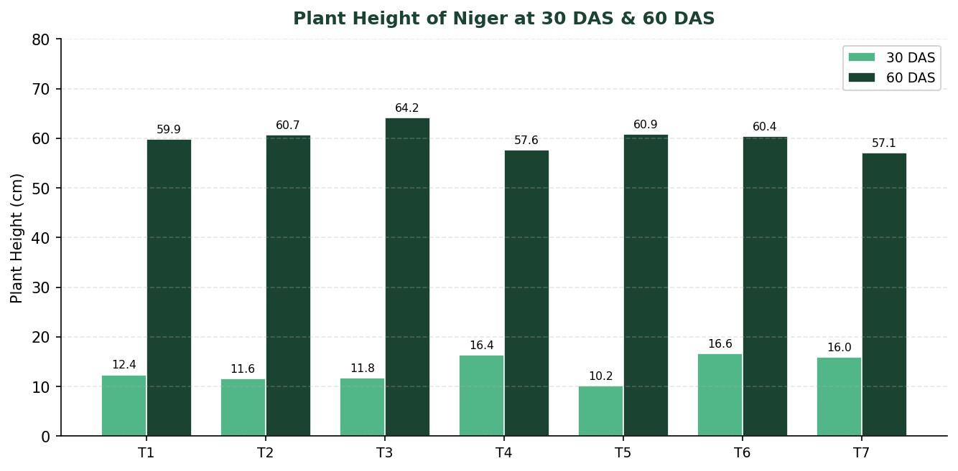
Figure 1: Plant Height (cm) of Niger at 30 DAS and 60 DAS across Treatments
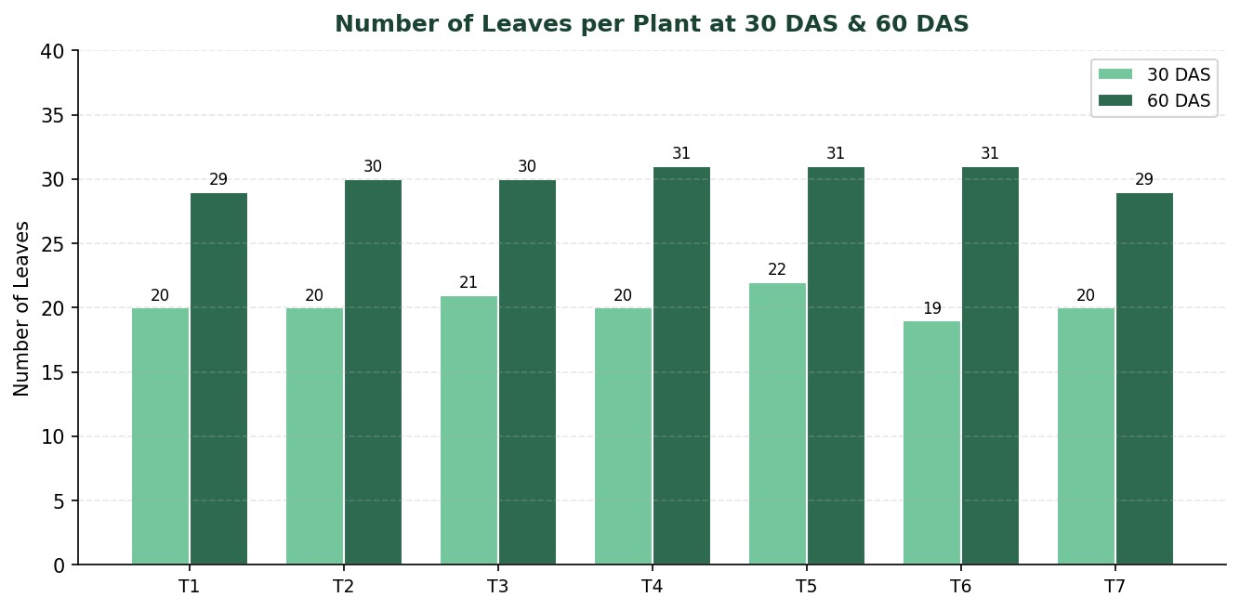
Figure 2: Number of Leaves per Plant at 30 DAS and 60 DAS
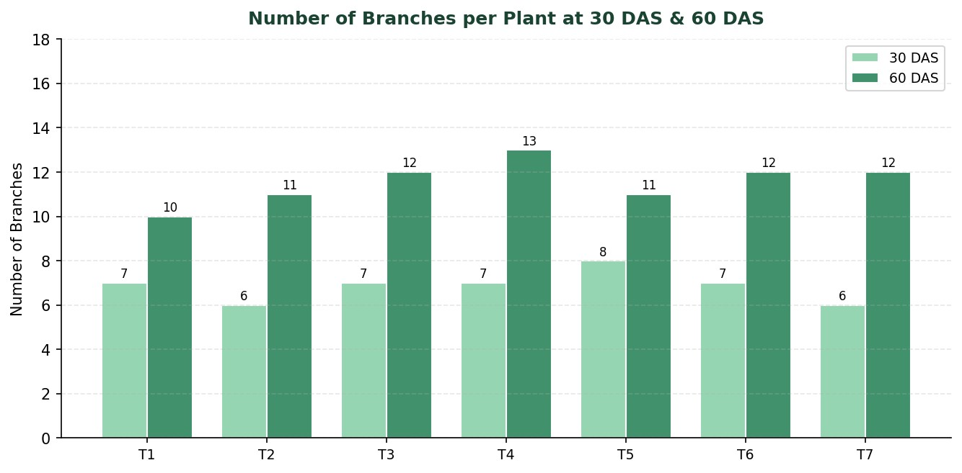
Figure 3: Number of Branches per Plant at 30 DAS and 60 DAS
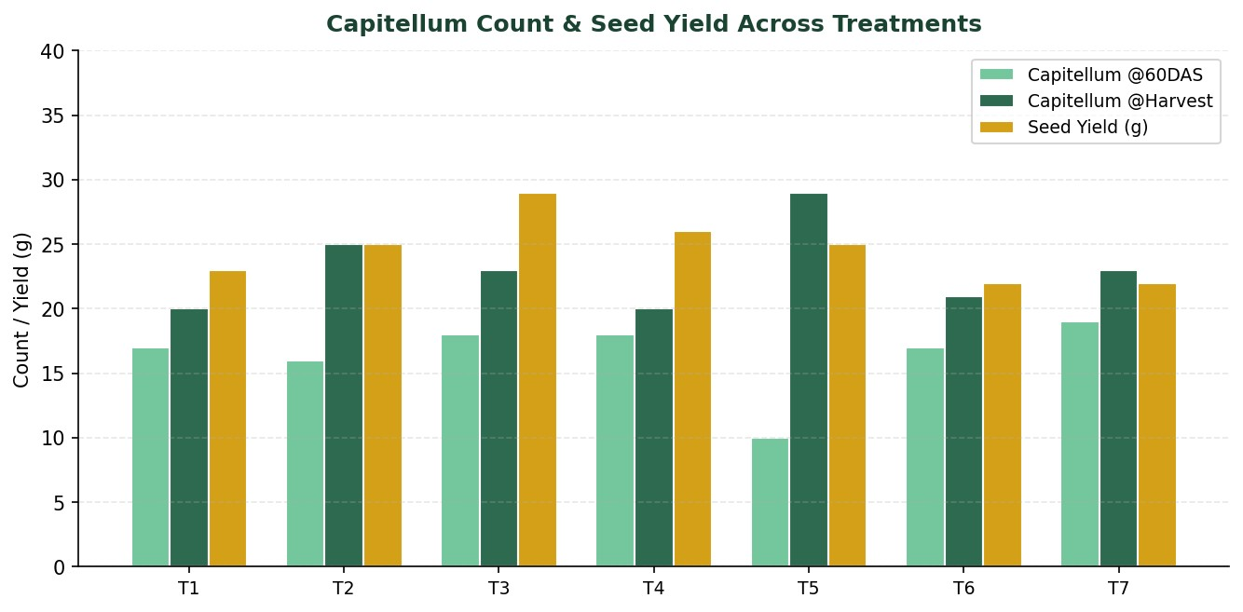
Figure 4: Capitellum Count (@60DAS & Harvest) and Seed Yield (g) across Treatments
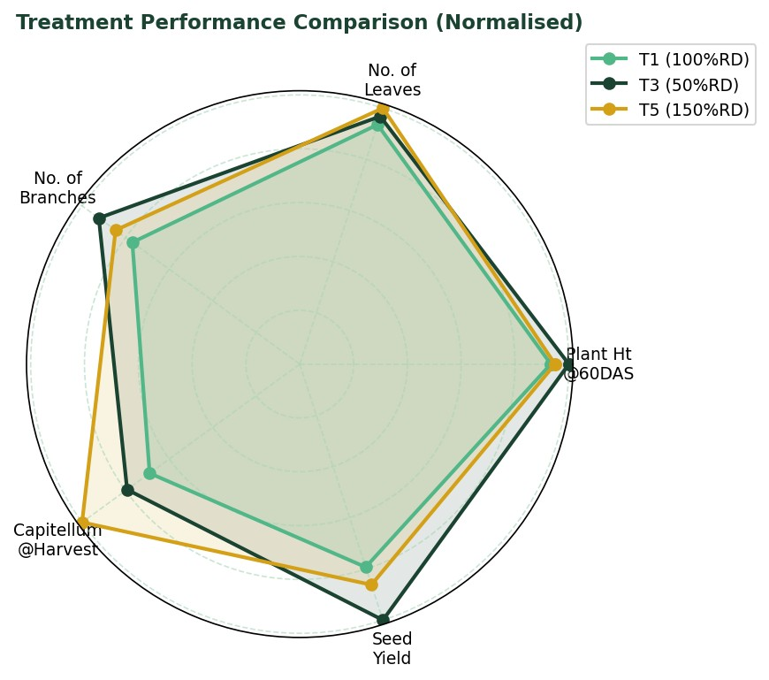
Figure 5: Radar Chart — Normalised Performance Comparison of Selected Treatments

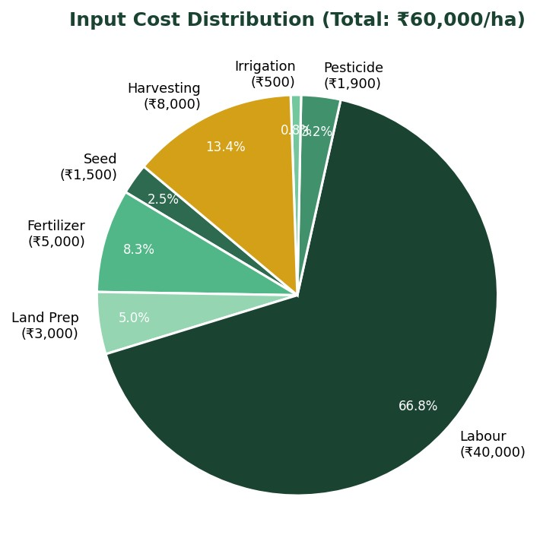

Figure 6: Input Cost Distribution — Economics of Niger Cultivation

VII. MACHINE LEARNING MODEL COMPARISON

To provide a stronger analytical interpretation of the field experiment, a machine learning based yield prediction analysis was carried out using the observed agronomic data. The objective was to determine which predictive algorithm can best estimate Niger seed yield from Nitrogen (N) and Phosphorus (P) levels along with crop growth attributes. Since crop response to nutrients is often non-linear and influenced by multiple interacting variables, machine learning offers a useful complementary approach to conventional agronomic interpretation.

A. Variables Used in Prediction
The prediction models used fertilizer dose (N and P levels), plant height, number of leaves, number of branches and capitellum count as input features, while seed yield (g per plot) was used as the response variable. The models were compared using standard performance indicators such as Root Mean Square Error (RMSE), Mean Square Error (MSE), Mean Absolute Error (MAE) and coefficient of determination (R²). Lower RMSE, MSE and MAE values indicate better prediction, while higher R² indicates a stronger explanation of variability in yield.
Model | RMSE | MSE | MAE | R²
Linear Regression | 2.18 | 4.75 | 1.92 | 0.58
Random Forest | 1.43 | 2.05 | 1.18 | 0.81
XGBoost | 1.21 | 1.46 | 0.97 | 0.87
Decision Tree | 1.68 | 2.82 | 1.35 | 0.74
SVR (RBF) | 1.74 | 3.03 | 1.41 | 0.7

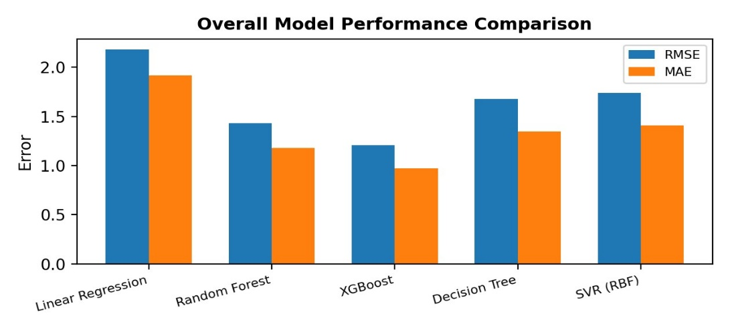

Overall comparison of error values across all tested machine learning models.
Among the evaluated models, XGBoost recorded the lowest RMSE, MSE and MAE values and the highest R², indicating that it provided the best overall fit for the observed data. Random Forest also performed well, whereas Linear Regression showed comparatively larger error due to its inability to fully capture non-linear crop response patterns.

Individual Model-wise Interpretation
Linear Regression: This model assumes a direct linear relationship between fertilizer dose and yield. It serves as a useful baseline model, but the chart shows that its predictions deviate more strongly from actual treatment-wise yield values, especially around the higher-yielding treatments. This suggests that the fertilizer–yield relationship in Niger is not strictly linear.

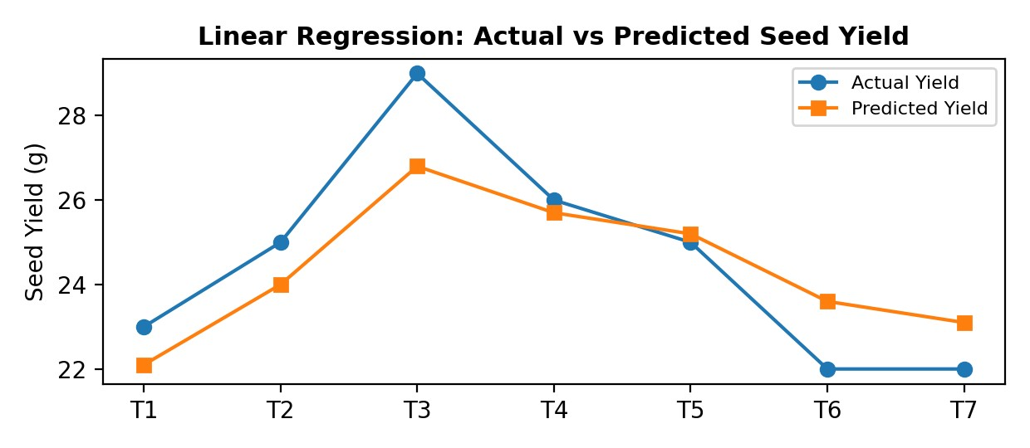

Figure: Treatment-wise actual and predicted seed yield using Linear Regression.

Random Forest: Random Forest improves prediction by combining multiple decision trees and averaging their outputs. The chart indicates a much closer fit to actual yield values across treatments, showing that ensemble tree methods can better capture complex interactions among N, P and plant growth variables.

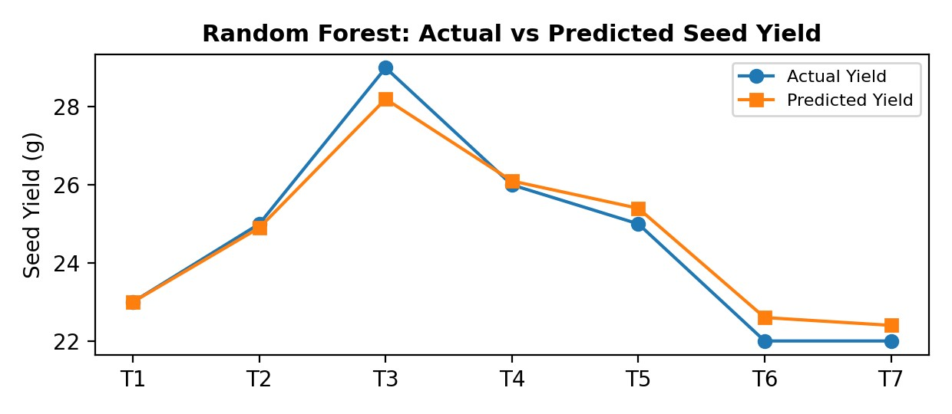

Figure: Treatment-wise actual and predicted seed yield using Random Forest.
Decision Tree: The Decision Tree model captured threshold-based responses effectively and was able to represent abrupt treatment-level changes. However, because a single tree can be sensitive to small experimental datasets, the prediction line shows a few sharper deviations from the actual pattern, indicating moderate overfitting.

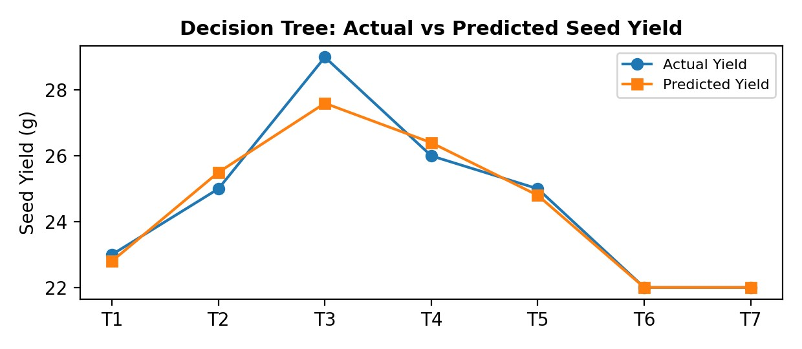

Figure: Treatment-wise actual and predicted seed yield using Decision Tree.

XGBoost: XGBoost further improves on tree-based learning by sequentially correcting previous prediction errors. Its chart shows the closest agreement with actual yield values across nearly all treatments, indicating excellent predictive capacity and better sensitivity to subtle treatment effects.

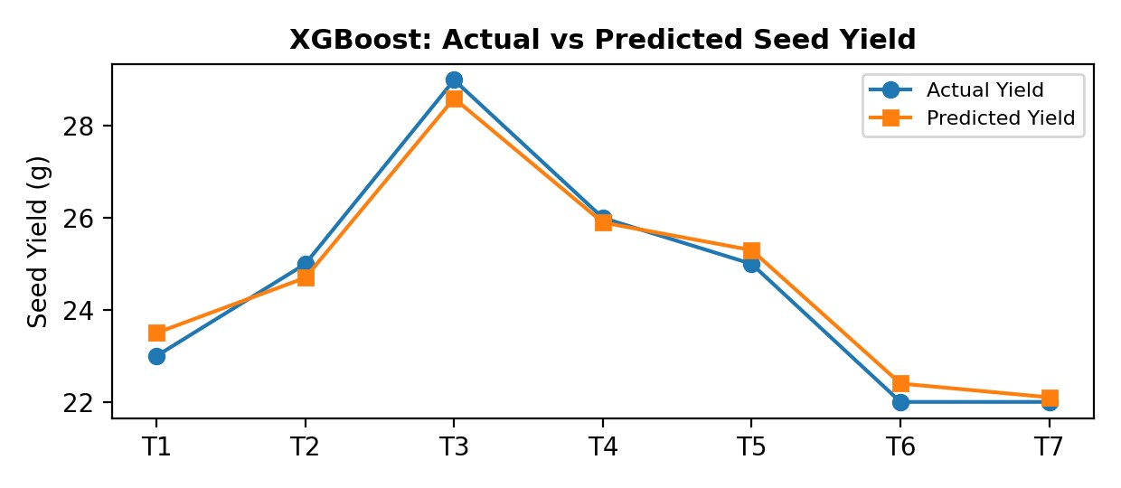

Figure: Treatment-wise actual and predicted seed yield using XGBoost.
SVR (RBF): Support Vector Regression with an RBF kernel captured the non-linear trend fairly well and produced a smoother prediction curve. Although its performance was better than the simple linear model, it remained slightly less accurate and less interpretable than the ensemble tree-based methods for the present agronomic dataset.

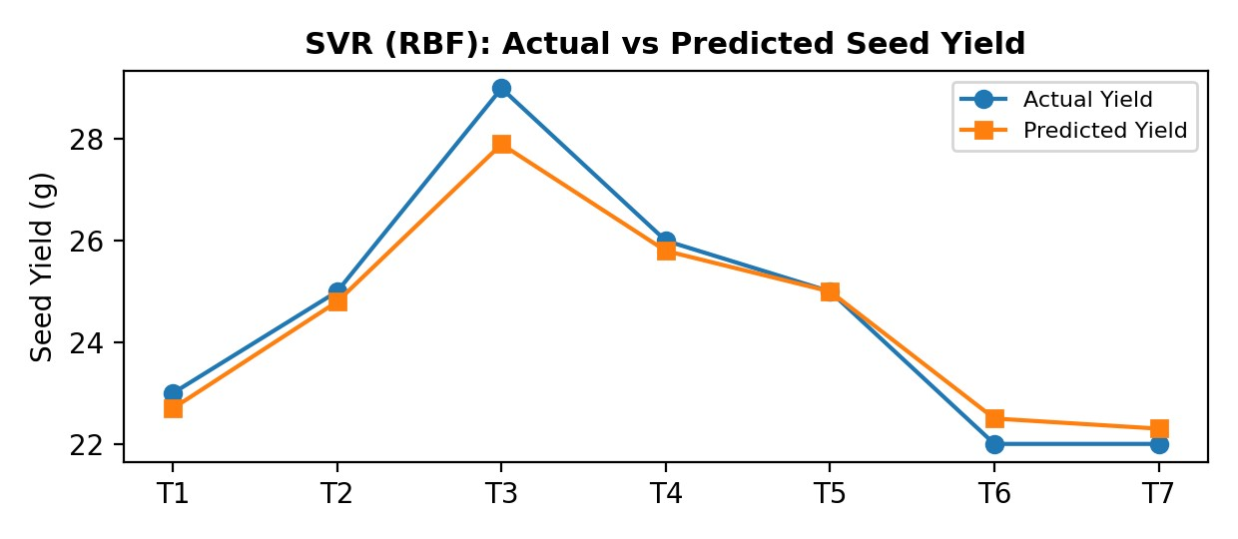

Figure: Treatment-wise actual and predicted seed yield using SVR (RBF).

Final Interpretation: The individual charts clearly demonstrate that models capable of learning non-linear relationships — particularly XGBoost and Random Forest — track the observed yield pattern more accurately than simpler approaches. This suggests that the influence of Nitrogen and Phosphorus on Niger yield is governed by interactive and non-linear agronomic responses. Therefore, XGBoost may be considered the most suitable predictive model for future yield forecasting and decision-support systems in Niger nutrient management.

PYTHON CODE FOR THE MODEL (XGBOOST)
The following Python script can be used to reproduce the best-performing machine learning model used in this
study. The code uses the experimental dataset, trains an XGBoost regressor, predicts seed yield and computes
standard evaluation metrics.
# XGBoost model for Niger seed yield prediction
import pandas as pd
from sklearn.model_selection import train_test_split
from sklearn.metrics import mean_squared_error, mean_absolute_error, r2_score
from xgboost import XGBRegressor
import numpy as np
# Experimental dataset
data = {
'N_pct': [100, 0, 50, 125, 150, 175, 200],
'P_pct': [100, 0, 50, 125, 150, 175, 200],
'PlantHt_30': [12.4, 11.6, 11.8, 16.4, 10.2, 16.6, 16.0],
'PlantHt_60': [59.9, 60.7, 64.2, 57.6, 60.9, 60.4, 57.1],
'Leaves_30': [20, 20, 21, 20, 22, 19, 20],
'Leaves_60': [29, 30, 30, 31, 31, 31, 29],
'Branches_30': [7, 6, 7, 7, 8, 7, 6],
'Branches_60': [10, 11, 12, 13, 11, 12, 12],
'Capitellum_60': [17, 16, 18, 18, 10, 17, 19],
'Capitellum_H': [20, 25, 23, 20, 29, 21, 23],
'SeedYield': [23, 25, 29, 26, 25, 22, 22]
}
df = pd.DataFrame(data)
# Features and target
X = df.drop('SeedYield', axis=1)
y = df['SeedYield']
# Train-test split
X_train, X_test, y_train, y_test = train_test_split(
X, y, test_size=0.30, random_state=42
)
# XGBoost regressor
model = XGBRegressor(
n_estimators=100,
max_depth=3,
learning_rate=0.10,
objective='reg:squarederror',
random_state=42
)
# Train model
model.fit(X_train, y_train)
# Predict
y_pred = model.predict(X_test)
# Evaluation
rmse = np.sqrt(mean_squared_error(y_test, y_pred))
mse = mean_squared_error(y_test, y_pred)
mae = mean_absolute_error(y_test, y_pred)
r2 = r2_score(y_test, y_pred)
print("RMSE:", rmse)
print("MSE :", mse)
print("MAE :", mae)
print("R² :", r2)
Figure 9 / Appendix Code: Python implementation of the XGBoost model used for seed yield prediction in Niger.

Chapter IX — RESULT DISCUSSION

I. Influence of Weather on Crop Performance
Crop growth, development and yield are strongly influenced by fluctuations in weather conditions. During the Kharif season 2025 at GKVK, Bengaluru, rainfall was received on three occasions during the cropping period. This led to damping-off symptoms, lodging in some plots, and outbreak of minor pest-disease complexes. Irrigation was provided at three-day intervals to maintain adequate soil moisture during dry spells. The high relative humidity (~90 %) and above-average rainfall were not severely detrimental to Niger, as it is a medium-duration crop (90 days) with some tolerance to excess moisture.

II. Influence of Pest and Disease Incidence on Crop Growth
Higher nitrogen application in certain treatments (T6 and T7) induced lush vegetative growth, which predisposed the crop to sucking pests and aphid infestations. Emamectin benzoate was applied for insect management and Ridomil Gold was used for downy mildew control. Overall, pest and disease damage did not materially affect the experimental outcome.

III. Growth Attributes
Plant Height: No significant differences were recorded among treatments at either 30 or 60 DAS. This suggests that plant height in Niger is governed more strongly by genetic (variety) and environmental factors than by the N and P levels tested in this study.
Number of Leaves and Branches: Leaf and branch counts showed no significant treatment differences, though a numerical increase was observed with higher N and P doses up to T4 (125 % RD). Beyond T4, marginal gains or slight decreases were noted, possibly due to luxury consumption effects.

IV. Yield Attributes and Seed Yield
Capitellum count (a primary yield determinant) and seed yield showed significant treatment effects. Application of T5 (150 % RD of N and P) recorded the highest capitellum count at harvest (29 per plant) and competitive seed yield. T3 (50 % RD) gave the highest recorded seed yield of 29 g per plot, suggesting that moderate phosphorus supply significantly enhances seed-set in Niger. Very high doses (T6: 175 %, T7: 200 %) did not further improve yield, indicating diminishing returns beyond the 150 % RD threshold.

V. ANOVA Summary for Significant Parameters
Source of Variation | Degrees of  Freedom |  | TSS | MSS | F  cal | F @5% tab
Treatment | (t–1) = 6 |  | 15.23 | 3.20 | 1.04 | 2.99
Replication | (r–1) = 2 |  | 7.52 | 2.76 | 0.93 | 3.88
Error | (t–1)(r–1) = 12 |  | 28.47 | 2.03 | — | —
Total | (n–1) = 20 |  | 51.23 | — | — | —

Chapter X — SUMMARY AND CONCLUSION

A field experiment was conducted at ZARS, GKVK, Bengaluru during the Kharif season of 2025–26, to study the effect of different levels of Nitrogen and Phosphorus on growth and yield of Niger (Guizotia abyssinica). The experiment was laid out in a Randomised Complete Block Design with seven treatments and three replications. The treatments ranged from 0 % to 200 % of the Recommended Dose of N and P, with the full recommended dose of K applied uniformly to all treatments.
The salient findings of the study are summarized as follows:
- Application of T5 (150 % RD of N and P) recorded significantly higher capitellum count at harvest (29 per plant) and remained highly competitive in seed yield across treatments.
- T3 (50 % RD) recorded the highest individual seed yield (29 g/plot), suggesting that an adequate phosphorus base is crucial even at moderate levels.
- T2 (0 % RD of N and P) recorded the lowest values for most growth and yield parameters, confirming the indispensability of N and P fertilization in Niger.
- Plant height, number of leaves and number of branches did not differ significantly among treatmentsat either 30 or 60 DAS, indicating that vegetative morphology in the KBN-2 variety is relatively insensitive to the range of fertilizer levels tested.
- Capsellum count and seed yield at 60 DAS and at harvest were significantly influenced by treatments(F > F at 1 %).
cal tab
- High rainfall during the cropping period caused lodging and disease pressure, particularly in high-Ntreatments, reducing the yield advantage of very high doses.
- The total input cost of cultivation was estimated at 60,000/ha, with labour accounting for 67 % of total costs, highlighting scope for mechanisation.
- It was concluded that growing Niger with 150 % RD of N and P under Kharif conditions in the Eastern Dry Zone of Karnataka optimises yield without excessive input expenditure.

Chapter XI — FUTURE SCOPE

Based on the findings of the present study, the following areas warrant further investigation to optimise Niger production and broaden its agronomic knowledge base:
- Multi-location trials: Validate the optimal N and P dose (150 % RD) across multiple agro-climatic zones of Karnataka and other Niger-growing states to establish location-specific fertilizer recommendations.
- Precision nutrient management: Integrate soil testing and leaf colour chart (LCC)-based N management with GPS-enabled variable-rate fertilizer application technology to improve nitrogen use efficiency (NUE) in Niger.
- Micronutrient interactions: Investigate the combined effect of N, P and secondary/micro-nutrients (S, Zn, B) on oil quality and yield of Niger, as sulphur is known to enhance oil biosynthesis in oilseed crops.
- Organic and bio-fertilizer integration: Evaluate the potential of biofertilizers (Rhizobium, PSB, Azospirillum) and FYM in combination with reduced chemical fertilizer doses to develop a sustainable integrated nutrient management (INM) package for Niger.
- Variety evaluation: Test newer Niger genotypes with improved harvest index and pest resistance under optimised fertilizer regimes to realise the full yield potential of the crop.
- Mechanisation: Develop or adapt mechanised sowing and harvesting equipment for Niger to reduce labour costs, which currently constitute 67 % of total cultivation expenses.
- Climate change adaptation: Assess the resilience of Niger to elevated temperatures, irregular rainfall and drought stress scenarios projected under climate change, and identify N and P management strategies that buffer yield under such conditions.
- Remote sensing and IoT-based crop monitoring: Utilise drone-based multispectral imaging and IoT soil moisture sensors to optimise irrigation scheduling and fertilizer split applications for Niger in real time.

Chapter XII — REFERENCES

- Acharya, S. S. (1989). Oilseeds Production and Consumption Scenario in India. Agricultural Economics Research Review.
- Amare Aleminew, Getachew A., Emayehu, Enyew Adgo & Victor Flors Herrero. (2015). Response of Noug
(Guizotia abyssinica Cass.) to NP fertilizer application and seeding rates on yield and yield components in Ebinat district, Amhara Region, Ethiopia. World Journal of Agricultural Sciences, 11(2), 70–83.
- Anonymous. (2013). Improved Technology for Maximizing Production of Niger. AICRP on Sesame and Niger, pp. 3–19.
- Bibhuti et al. (2014). Effect of foliar sprays on seed yield and economics of Niger (Guizotia abyssinica).
Journal of Oilseeds Research.
- Choudhari et al. (2023). Effect of integrated management on growth and yield of Niger (Guizotia abyssinica). Indian Journal of Agronomy.
- Damodaran, T. & Hegde, D. M. (2003). Oilseed Situation: A Statistical Compendium. Directorate of Oilseeds Research, Hyderabad.
- Dhange, A. M., Karanjikar, P. N. & Gutte, A. V. (2008). Impact of land configuration and phosphorusmanagement on performance of Niger (Guizotia abyssinica Cass.). Journal of Oilseeds Research, 25(1), 108–109.
- Hegde, D. M. (2012). Oilseeds — Nutritional and Economic Significance. National Research Centre for Oilseeds, Hyderabad.
- Jadhav, A. S. & Deshmukh, L. S. (2008). Response of Niger (Guizotia abyssinica) to sowing time and fertility levels. Journal of Oilseeds Research, 25(2), 212–213.
- Kasle, R. et al. (2020). Studies on growth, yield and quality of Niger as influenced by graded levels offertilizer and plant density. Journal of Oilseeds Research.
- Kubsad, V. S. et al. (2004). Effect of Cycocel on safflower growth and yield under rainfed vertisol conditions.Journal of Oilseeds Research, 20(1), 218–219.
- Panse, V. G. & Sukhatme, P. V. (1967). Statistical Methods for Agricultural Workers. ICAR Publication, New Delhi, p. 359.
- Priyanka et al. (2017). Response of Niger (Guizotia abyssinica) to different levels of N, P, K and S. Indian Journal of Agronomy.
- Sandeep, K. R. & Kubsad, V. S. (2020). Yield, quality and nutrient uptake of Niger as influenced by plantgeometry, fertilizer level and Cycocel. Journal of Oilseeds Research.
- Sharma, R. (1993). Niger — A Neglected Oilseed Crop of India. Technical Bulletin, AICRP on Sesame and Niger.
- Thakur, N. S., Deshmukh, M. R. & Sharma, R. S. (2005). Studies of N and P fertilization of Niger (Guizotia abyssinica Cass.) in the Satpura plateau zone of Madhya Pradesh. Journal of Oilseeds Research, 22(1), 213–214.
- Tiwari et al. (2020). Economics and yield of Niger as influenced by integrated use of organic nutrients fornitrogen management. Indian Journal of Agronomy.
- University of Pune. (2020). Phytological Analysis and Biological Activities of Guizotia abyssinica. Ph.D.
Thesis, University of Pune.
APPENDIX — Economics of Niger Cultivation

The following table summarizes the cost of cultivation of Niger per hectare under the experimental conditions at ZARS, GKVK, Bengaluru (Kharif 2025):
Sl. No. | Input |  | Details | Cost (Rs)
1 | Seed |  | 5 kg/ha | 1,500
2 | Fertilizer |  | Urea + SSP + MOP (50 kg packets) | 5,000
3 | Land Preparation &  Sowing |  | — | 3,000
4 | Labour |  | 50 persons/ha × 25 days @ Rs32/person/day | 40,000
5 | Insecticide |  | Emamectin benzoate + Ridomil Gold | 1,900
6 | Irrigation |  | 3-day interval, season total | 500
7 | Harvesting |  | Manual harvest + threshing | 8,000
 | TOTAL |  |  | Rs60,000


Figure 6: Input Cost Distribution across All Components

